

CONTENT

Sl.No. | Date | Experiment Title | Page No
1. | 18-03-2024 | T Make any real time problem and do the following experiments. | 01
a) |  | Write down the problem statement for a suggested system of relevance. Develop Flow-Charts to understand basic problem-solving technique. | 02
b) |  | Do requirement analysis and develop Software Requirement Specification Sheet (SRS) for suggested system. | 03
c) |  | Using COCOMO model estimate effort. | 10
d) |  | P Perform Estimation of effort using FP Estimation for chosen system. | 13
e) |  | A Analyze the Risk related to the project and prepare RMMM plan. | 16
f) |  | Develop Time-line chart and project table using PERT or CPM project scheduling methods. | 19
g) |  | Draw E-R diagrams, DFD, CFD and structured charts for the project. | 20
h) |  | Design of Test cases based on requirements and design. | 23
i) |  | Prepare FTR.
j) |  | Prepare Version control and change control for software configuration items.
2. |  | Using UML/JAVA, design Abstract Factory design pattern.
3. |  | Using UML/JAVA, design Builder design pattern.
4. |  | Using UML/JAVA, design Façade design pattern.
5. |  | Using UML/JAVA, design Bridge design pattern.
6. |  | Using UML/JAVA, design Decorator design pattern.
7. |  | User gives a print command from a word document. Design to represent this chain of responsibility design pattern.

Experiment – 1 : Take any real time problem and do the following experiments.
Many farmers, especially in rural areas, lack timely and accurate information about market prices, demand trends, and agricultural inputs. As a result, they often struggle to make informed decisions regarding crop selection, pricing, and selling strategies. This lack of market intelligence leads to inefficiencies in agricultural production, lower income for farmers, and potential food wastage due to mismatches between supply and demand.

Experiment – 1.a: Write down the problem statement for a suggested system of relevance. Develop Flow-Charts to understand basic problem solving technique.

PROBLEM STATEMENT
The Online Agricultural Management System (OAMS) is designed to streamline and enhance the efficiency of agricultural processes through digital solutions. The system aims to assist farmers, agronomists, and agricultural businesses in managing various aspects of farming, including crop planning, soil analysis, pest control, irrigation, market forecasting, and sales management. The key functionalities of the system include

SYSTEM REQUIREMENTS
User Management: Registration and login for farmers, agronomists, and business owners.
Crop Management: Planning, monitoring,recording crop cycles, including planting, growing, and harvesting.
Soil and Weather Analysis: Providing real-time data on soil health and weather conditions to optimize farming practices.
Pest and Disease Management: Identifying and managing pests and diseases through data analysis and recommendations.
Irrigation Management: Efficiently managing water resources and scheduling irrigation based on soil and weather conditions.
Market Forecasting and Sales: Offering market trends and forecasting to help farmers make informed decisions about crop sales.
Inventory Management: Tracking inventory of seeds, fertilizers, and other farming supplies.
Financial Management: Managing finances, including tracking expenses, profits, and accessing loans or subsidies.

FLOWCHART

Experiment – 1.b: Do requirement analysis and develop Software Requirement Specification Sheet (SRS) for suggested system.

SOFTWARE REQUIREMENTS SPECIFICATION (SRS) INTRODUCTION

PURPOSE
The AI Home Energy Consumption Tracker project aims to empower users to monitor, analyze, and optimize their energy usage. By providing insights and recommendations, it promotes energy efficiency and sustainability in households. Objectives include enabling effective monitoring, facilitating data analysis, promoting energy saving opportunities, enhancing user engagement, and supporting environmental sustainability. Ultimately, the project aims to empower users to make informed decisions about their energy usage for a more sustainable lifestyle.

SCOPE
The scope of the AI Home Energy Consumption Tracker project encompasses the development of a user friendly application for monitoring and analyzing energy usage. Features include integration with smart energy meters or manual entry of utility bills, data processing for insights, personalized recommendations for energy saving opportunities, and interactive user dashboards. Limitations include the exclusion of hardware development for energy meters and the focus on residential energy consumption only, excluding commercial or industrial sectors. Additionally, the project does not cover utility billing or payment processing functionalities.

SYSTEM OVERVIEW SYSTEM DESCRIPTION
The AI Home Energy Consumption Tracker is a comprehensive application designed to help users monitor, analyze, and optimize their energy usage in residential settings. The system's purpose is to empower users with insights and recommendations to promote energy efficiency and sustainability.

USER INTERFACE
The frontend component that allows users to interact with the system through a web or mobile application. It includes features such as dashboard displays, data visualization tools, and user controls.
Data Collection Module: This component collects energy consumption data from various sources, including smart energy meters, utility bills, and manual user input. It ensures accurate and timely data acquisition for analysis.

DATA PROCESSING ENGINE
Responsible for processing and analyzing the collected energy consumption data. It employs machine learning algorithms and statistical techniques to identify consumption patterns, trends, and anomalies.

RECOMMENDATION ENGINE
Utilizes the analyzed data to generate personalized recommendations and energy saving tips for users. Recommendations are based on user preferences, historical usage data, and best practices in energy management.

ALERT SYSTEM
Notifies users of any abnormal energy usage patterns, potential energy saving opportunities, or system updates. Alerts are delivered through various channels, such as email, SMS, or push notifications.

DATABASE
Stores user profiles, energy consumption data, system configurations, and historical usage information. It ensures data integrity, security, and accessibility for authorized users.

FUNCTIONALITY
Users interact with the system through the user interface, where they can view their energy consumption metrics, receive recommendations, and manage their account settings.
The system collects energy consumption data from smart meters or manual input and processes it to generate insights and recommendations.
Users receive alerts and notifications about their energy usage patterns, potential savings opportunities, and system updates.
The system continuously learns from user behavior and feedback to improve the accuracy and relevance of its recommendations over time.

SYSTEM ARCHITECTURE
The AI Home Energy Consumption Tracker system comprises:
User Interface (UI): Provides a graphical interface for user interaction.
Data Collection Module: Gathers energy consumption data from various sources.
Data Processing Engine: Analyzes data using machine learning and statistical techniques. Recommendation Engine: Generates personalized energy saving recommendations.
Alert System: Notifies users of important events or updates.
Database Management System (DBMS): Stores and manages user data and system configurations.

INTERACTIONS
UI interacts with Data Collection Module for data retrieval. Data is processed by the Data Processing Engine.
Recommendations are provided by the Recommendation Engine. Alerts are triggered by the Alert System based on monitored patterns.
This architecture ensures efficient data processing, analysis, and presentation, empowering users to manage energy consumption effectively.

KEY FEATURES
Real Time Monitoring: Track energy usage instantly. Data Analysis: Gain insights into consumption patterns.
Personalized Recommendations: Receive tailored energy saving tips. User Friendly Interface: Intuitive design for easy navigation.
Alert System: Get notified of anomalies and opportunities. Customization: Adjust settings to fit individual needs.
Historical Analysis: Review past usage trends. Efficiency Tracking: Monitor progress toward goals. Integration: Seamlessly connect with smart devices. ASSUMPTIONS AND DEPENDENCIES ASSUMPTIONS
- Stable internet access for user interaction.
- Availability of energy data from smart meters or utility bills.
- User engagement with energy saving recommendations.
- Accuracy of external energy consumption data.
- Basic user understanding of energy concepts.

DEPENDENCIES
- Third party APIs for data retrieval.
- Compatibility with smart meters and IoT devices.
- Compliance with privacy regulations.
- Cooperation from utility providers.
- Reliable internet connectivity.
- Trained machine learning models for data analysis.

FUNCTIONAL REQUIREMENTS
Data collection is a critical component of the system, with automatic integration of data from external sources like market databases, government reports, and agricultural organizations. Additionally, the system should enable users to manually enter local market prices, demand trends, and other relevant information, along with agricultural input data such as seeds, fertilizers, and pesticides...
Data Processing: processing functionalities must ensure the accuracy and reliability of collected data by validating it and filtering out anomalies. This data should be securely stored in a structured database for easy retrieval and analysis. The system should be capable of performing advanced data analysis to identify trends, patterns, and anomalies in market data and agricultural inputs.
Visualization tools: Are necessary to present data through charts, graphs, and dashboards, providing users with clear insights into market conditions, pricing trends, and demand forecasts. AI-based personalized recommendations should be generated to assist farmers in making informed decisions regarding crop selection, pricing strategies, and optimal selling times.
Alert System: An alert system is crucial for notifying users of significant events such as price changes, demand fluctuations, and potential selling opportunities through notifications or messages. Ensuring the security of user data through encryption, authentication, and access control mechanisms is vital, along with maintaining high performance, reliability, and availability of the system. The system should also be designed for maintainability and portability, allowing for easy updates, modifications, and deployment across different platforms and devices.
Calibration: Calibration within the online agricultural marketing system involves the process of adjusting and fine-tuning data collection methods and algorithms to ensure the accuracy and consistency of the market data and recommendations generated. This includes periodically reviewing and updating the algorithms that analyze market prices, demand trends, and agricultural inputs to ensure they reflect current conditions accurately. These functional requirements collectively enable users to effectively monitor, analyze, and optimize their energy consumption through the AI Home Energy Consumption Tracker system.

NONFUNCTIONAL REQUIREMENTS PERFORMANCE
• Scalability: The system should be able to handle an increasing number of users and large volumes of data without performance degradation.
• Response Time: The system should provide quick response times for data retrieval, analysis, and user interactions, ensuring a smooth and efficient user experience.

AVAILABILITY
Planned Downtime: Any planned maintenance or downtime should be communicated to users in advance. Redundancy: Critical components should have backup systems to ensure continuous operation.
Load Balancing: Traffic should be evenly distributed across servers to prevent overloads.

SECURITY
• Data Protection: Implement encryption for data at rest and in transit to protect sensitive information from unauthorized access.
• Authentication and Authorization: Ensure secure user authentication and role-based access control to protect against unauthorized access and actions within the system.
• Compliance: Adhere to relevant regulations and standards for data protection and privacy,

MAINTAINABILITY
• Modularity: The system architecture should be modular, allowing for easy updates and maintenance.
• Documentation: Maintain detailed documentation for both users and developers.
• Code Quality: Follow best practices for coding standards to ensure readability and maintainability of the codebase

PORTABILITY
• Cross-Platform Compatibility: The platform should be accessible from various devices, including desktops, tablets, and smartphones.
• Cloud Compatibility: Ensure the platform can be easily deployed on various cloud service providers.

USER INTERFACE DASHBOARD DISPLAY
- Allow users to rearrange and prioritize widgets based on their preferences.
- Provide real-time notifications for new orders, inquiries, and important updates. Includes comparisons and trend analysis.

ALERTS AND WARNINGS
- Provide estimated delivery dates and tracking information to buyers.
- Notify sellers when their inventory levels for specific products are running low.
- Alert sellers and buyers about quality issues reported by customers or during inspections.

USER CONTROLS
- Intuitive input controls for data and settings.
- Enable users to track the status of their orders from placement to delivery.
- Provide tools for generating invoices and managing payment records..

SYSTEM CONSTRAINTS
Hardware Constraints: The platform must be compatible with various devices and operating systems
Operational Constraints: Regular maintenance schedules and procedures to ensure system reliability, security patches, and updates.
Regulatory Constraints: Adherence to local and international regulations related to agriculture marketing, data privacy (e.g., GDPR, CCPA), and online commerce.
Environmental Constraints: Consideration of geographical variations in user demographics, agricultural practices, and market dynamics that may impact platform usability and relevance.

APPENDICES GLOSSARY
Market Intelligence System: A tool that collects and analyzes market data, including prices and demand trends, to provide actionable insights for decision-making in agriculture.
Manual Entry: The process of inputting data into the system manually, typically done by users entering information about local market prices or agricultural inputs directly into the application.
Data Processing: The manipulation and analysis of data to extract meaningful insights or information, such as identifying patterns, trends, or anomalies in market data and agricultural inputs.
Dashboard: A visual interface that displays key metrics, insights, and data summaries in a centralized location, providing farmers with an overview of market conditions, pricing trends, and demand forecasts.
Alert System: A feature that notifies users of important events or conditions, such as significant price changes, demand fluctuations, or optimal selling times, typically through notifications or messages.

Calibration: The process of adjusting or fine-tuning data collection methods or algorithms to ensure accuracy and consistency in the market data and recommendations they generate.
Performance: The speed, responsiveness, and efficiency of the system in processing data, generating insights, and providing feedback to users.
Reliability: The ability of the system to consistently perform its intended functions accurately and dependably, without failures or errors.
Availability: The degree to which the system is accessible and operational when needed, typically measured as uptime or the percentage of time the system is available for use.
Security: Measures implemented to protect the confidentiality, integrity, and availability of data within the system, including encryption, authentication, and access control mechanisms.
Maintainability: The ease with which the system can be maintained, updated, and modified over time, including factors such as code readability, documentation, and modular design.
Portability: The ability of the system to be deployed and run on different platforms, environments, or devices without requiring significant modifications or adjustments.

TEST CASES
User Registration and Login: Ensure users can register and log in securely.
Sensor Integration: Verify accurate data collection from smart meters or manual entry.
Data Processing and Analysis: Confirm correct processing of energy data and generation of insights. User Interface: Validate clear and intuitive dashboard display and navigation.
User Interaction: Test ease of manual data input and customization of settings. Performance Testing: Ensure the system handles data volumes and usage loads effectively.
Security Testing: Verify robust encryption, authentication, and protection against vulnerabilities. Compatibility Testing: Validate functionality across browsers, devices, and operating systems.
Regression Testing: Confirm new updates don't reintroduce previously fixed issues.
STAKEHOLDER LIST
Farmers: Producers of agricultural products. Selling their products at fair prices, accessing wider markets.
Consumers: Buyers of agricultural products. Accessing fresh, high-quality produce at reasonable prices.
Platform Developers: Designers and developers of the online marketing system. Creating a user-friendly, secure, and efficient platform.
Agricultural Cooperatives: Organizations representing groups of farmers. Facilitating the sale of members' products, ensuring fair practices.
Logistics and Transportation Companies: Providers of transportation services for the delivery of agricultural products. Partnering with the platform to offer their services.
Financial Institutions: Providers of payment processing and financial services. Facilitating secure transactions, offering financial products to users.
Government Agencies: Regulators and supporters of agricultural activities. Ensuring compliance with regulations, promoting agricultural development.
Agricultural Input Suppliers: Sellers of seeds, fertilizers, equipment, etc. Reaching out to farmers with their products.
Experiment – 1.c: Using COCOMO model estimate effort. BASIC COCOMO MODEL
The Basic COCOMO model is a straightforward way to estimate the effort needed for a software development project. It uses a simple mathematical formula to predict how many person-months of work are required based on the size of the project, measured in thousands of lines of code (KLOC).

INTERMEDIATE COCOMO MODEL

The basic COCOMO model assumes that the effort is only a function of the number of lines of code and some constants evaluated according to the different software systems. However, in reality, no system’s effort and schedule can be solely calculated based on Lines of Code. For that, various other factors such as reliability, experience, and Capability. These factors are known as Cost Drivers (multipliers) and the Intermediate Model utilizes 15 such drivers for cost estimation.

DETAILED COCOMO MODEL

Detailed COCOMO goes beyond Basic and Intermediate COCOMO by diving deeper into project-specific factors. It considers a wider range of parameters, like team experience, development practices, and software complexity. By analyzing these factors in more detail, Detailed COCOMO provides a highly accurate estimation of effort, time, and cost for software projects. It’s like zooming in on a project’s unique characteristics to get a clearer picture of what it will take to complete it successfully.

CALCULATION

BASIC COCOMO MODEL

Project Size: 10000 lines of code (LOC) COCOMO Model: Organic
EAF: 1.0(Neutral Adjustment)

Effort(E) = 𝑎 ∗ (𝐾𝐿𝑂𝐶)^{𝑏} ∗ 𝐸𝐴𝐹

a = 2.4 ,a = 1.05 ,Size = 10000 LOC(KLOC) ,EAF = 1.0

Effort(E) = 2.4 * (10)^{1.05}

≈ 2.4 ∗ 11.047

≈ 26.5128 𝑃𝑒𝑟𝑠𝑜𝑛𝑠 − 𝑀𝑜𝑛𝑡ℎ𝑠

𝐸 ≈ 27

Time(T) = 𝑐 ∗ (𝐸)^{𝑑}

= 2.5∗ (27)^{0.38}

= 2.5∗ 3.4987

= 8.7465

(𝑇) ≈ 9
People Required = 𝐸
𝑇

= 27
9
= 3(Persons Required)

INTERMEDIATE COCOMO MODEL

For this project we having considering the values for developer having very low in programming languages experience (PCAP), very high in required software reliability extent (RELY), Nominal in application of software engineering methods (MODP).
- Very low in programming language experience (PCAP) = 1.42
- Very high in required software reliability extent (RELY) = 1.40
- Nominal in application of software engineering methods (MODP) = 1.00 EAF = Effort Adjustment Factor
EAF = 1.42 x 1.40 x 1.00
EAF = 1.988

Here, a = 2.4, b = 1.05, c = 2.5, d = 0.38, lines of code = 39000 Effort (E) = 𝑎 ∗ (𝐾𝐿𝑂𝐶)^{𝑏} ∗ 𝐸𝐴𝐹
= 2.4 ∗ (39)^{1.05} ∗ 1.988

𝐸 ≈ 223

Time(T) = 𝑐 ∗ (𝐸)^{𝑑}

= 2.5∗ (223)^{0.38}

(𝑇) ≈ 20

Persons – Required = 𝐸
𝑇

= 223
20
= 11 (Persons Required)

Experiment – 1.d: Perform Estimation of effort using FP Estimation for chosen system.

To perform Function Point (FP) estimation for the Online Agricultural Marketing System, we need to break down the application into various functional components and then estimate the effort required for each component.
Identity the functional user requirements

User Registration and Authentication

• User Registration
• User Authentication
• Password Management
1.User Profile Management
• Profile Update: Enable users to update their profile information (contact details, address, payment preferences).
• Profile View: Allow users to view their profile information
2.Product Management
• Product Listing: Allow farmers to add new products with details such as name, category, price, quantity, and description.
• Product Editing: Enable farmers to edit product details.
• Product Deletion: Allow farmers to remove products from the listing.
3.Search and Browse
• Product Search: Enable consumers to search for products using keywords, categories, and filters (price range, location, etc.).
• Product Browsing: Allow consumers to browse through product categories and listings.
4.Order Management
• Add to Cart: Allow consumers to add products to a shopping cart.
• Cart Management: Enable consumers to view, update, and remove items from their cart.
5.Payment Processing
• Payment Options: Integrate multiple payment methods (credit/debit card, bank transfer, digital wallets).

External Inputs (EI)
• login, registration, product addition- 20
External Output (EO)
• confirmation messages - 5
• sales reports - 5
External Inquiries (EQ)

• product search - 10
• order status check - 5
Internal Logical Files (ILF)
• user data- 3
• product data - 2 External Interface Files (EIF)
• payment gateway data – 3
The Counts are
• Number of External Inputs (EI): 20
• Number of External Outputs (EO): 10
• Number of External Inquires (EQ): 15
• Number of Internal Logical Files (ILF): 5
• Number of External Interface Files (EIF): 3

These counts are essential for further analysis in estimation such as Function point analysis.

Compute the Unadjusted Function Points (UFP)

UFP = ∑(𝐶𝑜𝑢𝑛𝑡 ∗ 𝑤𝑒𝑖𝑔ℎ𝑡)

Or

UFP = ∑5 ∑3
𝑧𝑖𝑗𝑤𝑖𝑗
𝑖=1 𝑗=1
𝑤𝑖𝑗 = It is entry of the 𝑖𝑡ℎ row and 𝑗𝑡ℎ column of the table.

𝑧𝑖𝑗 = It is the count of number of functional units of type I that have been classified as having the complexity corresponding to columns.

 | Low | Average | High
External Inputs (EI) | 3 | 4 | 6
External Outputs (EO) | 4 | 5 | 7
External Inquires (EQ) | 3 | 4 | 6
Internal Logical Files (ILF) | 7 | 10 | 15
External Interface Files (EIF) | 5 | 7 | 10

UFP = 80 + 50 + 60 + 50 + 21 = 261

Calculate the value Adjustment Factor (VAF)
Let’s assume average complexity rating of 3 for all. Degree of Influence = 14 x 3 = 42
VAF = 0.65 + (0.01 x Total Degree of Influence) Let’s calculate the Adjusted Function Points (AFP) AFP = UFP X VAF
= 261 x 1.07

AFP = 279.27

Estimation Effort

Effort = 𝐴𝐹𝑃
𝑃𝑟𝑜𝑑𝑢𝑐𝑡𝑖𝑛𝑔 𝑅𝑎𝑡𝑒

= 279.27
15
𝐸𝑓𝑓𝑜𝑟𝑡 ≈ 19 𝑃𝑒𝑟𝑠𝑜𝑛𝑠 − 𝑀𝑜𝑛𝑡ℎ𝑠
Experiment – 1.e: Analyze the Risk related to the project and prepare RMMM plan.

Creating a Risk Mitigation, Monitoring, and Management (RMMM) plan for the Online Agricultural Management System involves identifying potential risks, assessing their impact and likelihood, and outlining strategies to mitigate or manage these risks throughout the project lifecycle.
RISK IDENTIFICATION TECHNICAL RISKS
  - Integration Complexity: Difficulty integrating different modules or third-party APIs.
  - Technology Obsolescence: Rapid changes in technology affecting system components.
  - Performance Issues: System scalability and response time under heavy load..

OPERATIONAL RISKS

  - Development Delays: Delays in the development phase due to unforeseen technical challenges.
  - Resource Availability: Lack of skilled personnel, particularly in AI and data integration.
  - Regulatory Compliance: Failure to meet legal or industry standards. privacy and energy usage.

Risk Mitigation Strategies

  - Budget Overruns: Project costs exceeding the initial budget due to underestimation of resources or unexpected expenses.
  - Funding Shortfalls: Insufficient funding to complete the project or maintain operations post-launch.

Risk Communication and Reporting

  - Reporting: Regular updates on risk status to project stakeholders.
  - Escalation: Procedures for escalating risks that exceed predefined thresholds.
  - Throughout the development cycle.

SECURITY RISKS

  - Data Breaches: Unauthorized access to user data leading to privacy issues.
  - System Vulnerabilities: Potential vulnerabilities in the application that can be exploited by attackers.

RISK ANALYSIS
Each identified risk is analyzed based on its likelihood and impact, and prioritized accordingly.
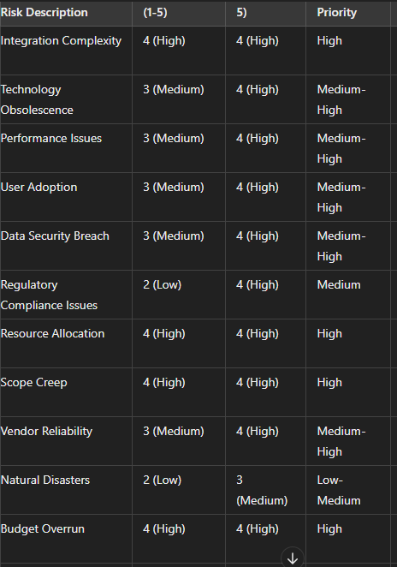

RISK ASSESSMENT
For an Online Agricultural Management System, key risks include technical issues like compatibility and cyber security, operational challenges such as data processing delays and market volatility, and environmental factors like weather fluctuations and regulatory changes.

RISK MONITORING AND REVIEW
Risk monitoring and review are critical aspects of ensuring the ongoing success and resilience of any project, including an Online Agricultural Management System. This involves regularly assessing identified risks, tracking their status and impact, and evaluating the effectiveness of mitigation measures.

RMMM PLAN SUMMARY TABLE FOR AI HOME ENERGY CONSUMPTION TRACKER PROJECT

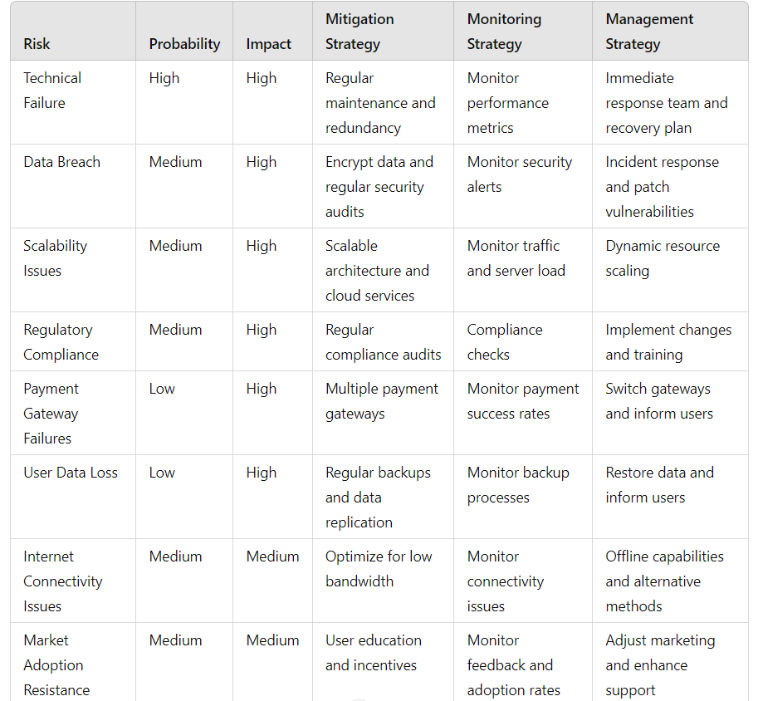
Experiment – 1.f: Develop Time-line chart and project table using PERT or CPM project scheduling methods.
To estimate the total cost for RMMM, we will sum up the costs for each mitigation strategy.

Mitigation Strategy | Estimated Cost ($)
Partner with smart meter manufacturers | 10,000
Implement advanced encryption and security | 12,000
Regular audits and compliance checks | 8,000
Develop robust validation algorithms | 10,000
Continuous model training and validation | 17,000
Implement redundant systems and backups | 9,000
Hire a compliance officer | 5,000
Develop user-friendly interfaces and tutorials | 7,000
Strict budget monitoring and control | 5,000
Use agile project management practices | 4,000
Total | 90,000

To calculate the RMMM cost estimation using the given formula:

The total estimated cost for implementing these mitigation strategies is $97,000. Assuming the total project cost is $500,000.
RMMM Cost Estimation = Total Cost of all Risks
Total Assumed Cost of RMMM

RMMM Cost Estimation = 90000
500000

RMMM Cost Estimation ≈ 0.18

This means that approximately 19.4% of the total project cost is allocated for managing and mitigating risks.

Experiment – 1.g: Draw E-R diagrams, DFD, CFD and structured charts for the project.

ER DIAGRAM

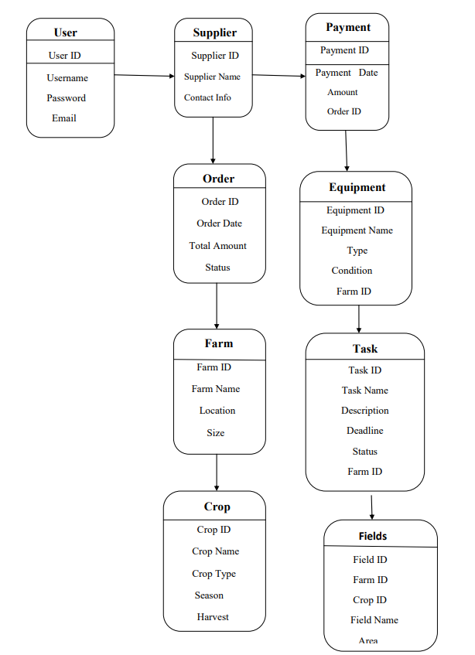

DATA FLOW DIAGRAMS (DFD)
DFD LEVEL – 0
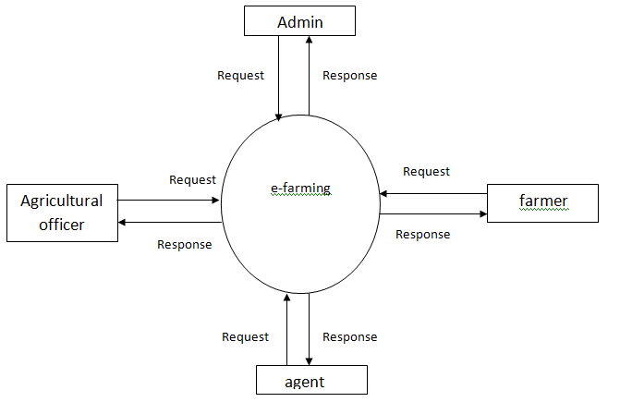

DFD LEVEL – 1
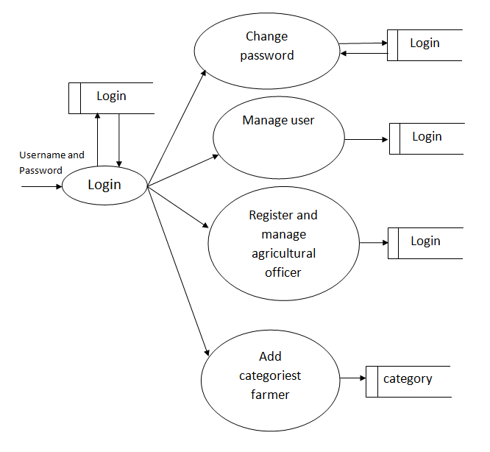

DATA FLOW DIAGRAMS (DFD)
Online Agricultural Management System
Admin
Supplier
Customers
Farmers
Database
STRUCTURED CHART

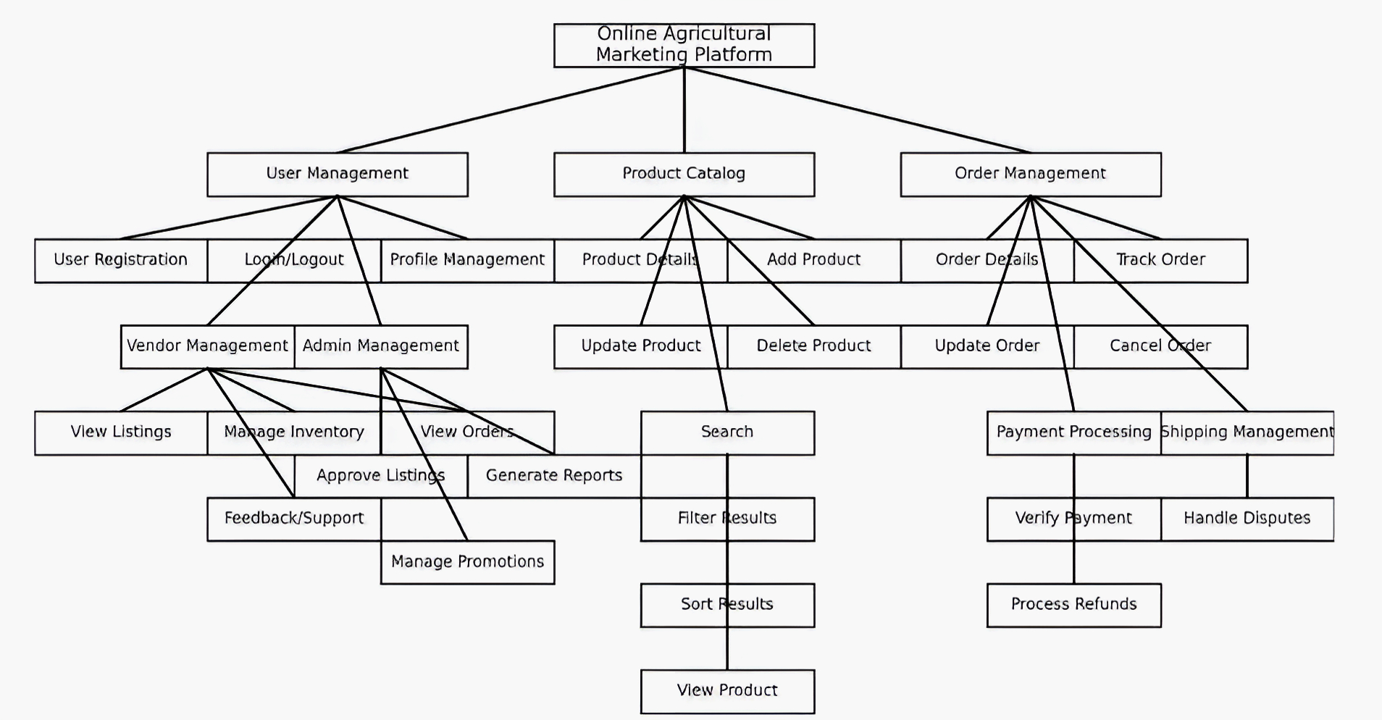
Experiment – 1.h: Design of Test cases based on requirements and design.
Module 1
Project Name: | Online Agricultural Management System
Module Name: | Login Name
Reference Document: | -
Created by: | V Venkat Kiran, V. Manikanta, S. Narayana
Date of creation:
Date of review:

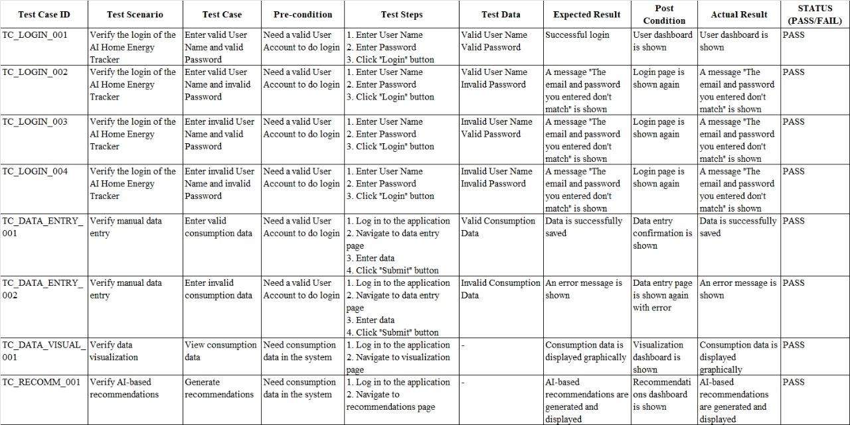

Experiment – 2: Using UML/JAVA, design Abstract Factory design pattern.

Abstract Factory: Declares an interface for creating abstract product objects.

Concrete Factory: Concrete implementation of the Abstract Factory to create actual products.

CropFactory and FertilizerFactory: Concrete factories that implement the AbstractFactory interface to create specific families of products

Wheat Product, Corn Product, Organic Fertilizer, Chemical Fertilizer: Concrete product classes that implement the Abstract Product interface.

Client: Uses the Abstract Factory and Abstract Product interfaces to interact with the products.

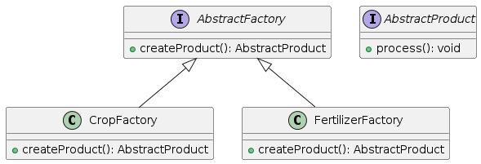

Experiment – 3: Using UML/JAVA, design Builder design pattern.

Crop Class (Product): Represents the complex object under construction.
CropBuilder Class (Builder): Contains methods to set the attributes of the Crop and a method build() to construct the Crop object.
Crop Director Class (Director): Constructs the Crop using the CropBuilder.
Main Class: Demonstrates how to use the Builder pattern to create a Crop object.

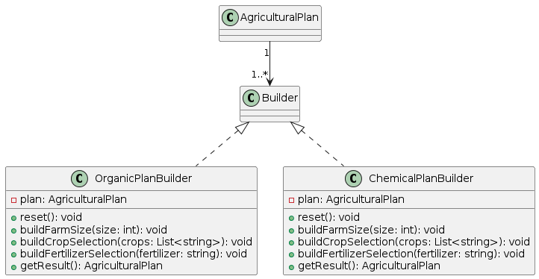
Experiment – 4: Using uml/java, design facade design pattern.

Crop Manager Class: Manages the operations related to crops.
Weather Service Class: Provides weather forecasting.
Inventory Manager Class: Manages inventory items.
Agricultural SystemFacade Class (Facade): Simplifies interactions with the system by providing methods that internally use the CropManager, WeatherService, and InventoryManager classes.

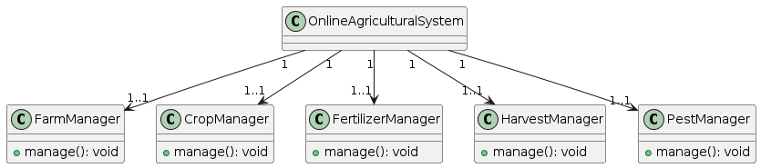
Experiment – 5: Using UML/JAVA, design Bridge design pattern.

Crop CropType Interface (Implementor): This interface defines the operations that can be implemented by different crop types.
OrganicType and ConventionalType Classes (ConcreteImplementors): These classes implement the ‘CropType’ interface.
Crop Class (Abstraction): This is the abstract class that contains a reference to a ‘CropType’ object.
Main Class: Demonstrates how to use the Bridge pattern by creating different combinations of crops and crop types.

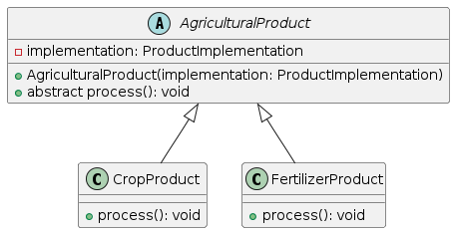
Experiment – 6: Using UML/JAVA, design Decorator design pattern.

Crop Interface (Component): This interface defines the operation ‘grow’ that can be altered by decorators.
Basic Crop Class (Concrete Component): This class implements the ‘Crop’ interface and provides the basic functionality of a crop.
Crop Decorator Class (Decorator): This abstract class implements the ‘Crop’ interface and contains a reference to a Crop object. It forwards the request to the decorated crop.
Fertilizer Decorator Class (Concrete Decorator): This class extends ‘CropDecorator’ and adds fertilizer functionality.
Pesticide Decorator Class (Concrete Decorator): This class extends ‘CropDecorator’ and adds pesticide functionality.
Main Class: Demonstrates how to use the Decorator pattern by creating different decorated crops.

